OMS L'occitane Docs Issues

# Issue Failed Posting Sales Order

* Problem : Failed Posting Sales Order :INVALID_FLD_VALUE details :The field custcol_aba_line_discount contained more than the maximum number ( 15 ) of characters allowed.
* Example Slack Thread Issue : <https://sirclo.slack.com/archives/CSJSZT20Z/p1665458683545519?thread_ts=1665451760.815269&cid=CSJSZT20Z>
* Reason : kolom custcol_aba_line_discount di kirim ke netsuite 8 angka dibelakang koma, alhasil kalo angka discountnya gede bakal lebih dari 15.
* Fixing : Dengan mengubah angka round (menambah) di fungsi getPriceExcludeTax
* Source :

<https://github.com/icube-mage/swiftoms-loccitane/blob/0e87100128b39a7ee0326202fd039a949696ee9c/app/code/LoccitaneOms/Netsuite/Helper/Xsl.php#L234><https://github.com/icube-mage/swiftoms-loccitane/blob/0e87100128b39a7ee0326202fd039a949696ee9c/app/code/LoccitaneOms/Netsuite/Helper/Xsl.php#L255>

# Issue Failed Push Order To Netsuite

* Problem : Gagal push order ke netsuite (order belum diterima netsuite)
* Example Slack Thread Issue :

<https://sirclo.slack.com/archives/CSJSZT20Z/p1673789742455079>

* Reason : dikarenakan ada order yang terlewat, bisa karena invalid email, terlewat cron, dll
* Fixing :

1. Mengecek export_progress, export_status, dan netsuite_internal_id, gagal dipush ke netsuite ditandai dengan netsuite_internal_id yang NULL
2. Check menggunakan QUERY ini

| SELECT oo.channel_order_increment_id, oo.inserted_at, oo.channel_code, so.entity_id as order_id, ss.entity_id as shipment_id, ss.increment_id, so.export_progress, so.export_status, so.netsuite_internal_id  FROM oms_order oo  LEFT JOIN sales_order so ON oo.oms_order_id = so.entity_id  LEFT JOIN sales_shipment ss ON so.entity_id = ss.order_id  WHERE oo.channel_order_increment_id IN ('masukin channel_order_increment_id'); |
| --- |

1. Keterangan flag :

export_progress : 1 -> queue, 2 -> order header, 3 -> payment, 4 -> fulfillment, 5-> success

export_status : 1 -> process , 2 -> success , 3 -> error

1. Kemudian check di table netsuite_log_export filter by shipment id jika terdapat error gara-gara invalid email, lakukan edit email di table sales_order dan sales_order_address.
2. Kemudian reset export_progress dan export_status menjadi NULL, dengan query

| UPDATE sales_order SET export_progress = NULL, export_status = NULL WHERE entity_id IN ('masukin entity id sales order'); |
| --- |

1. Kemudian tinggal tunggu cron untuk menjalankan export ke netsuite atau bisa dilakukan dengan manual push to netsuite

* Akses Backoffice > Sales > Sales Export > Export Profiles
* Misal yang akan diexport order dari loccitane, pilih profile [MANUAL] Netsuite Export LOCC > Filter / Actions > masukan increment_id (sales_shipment) yang akan di export.

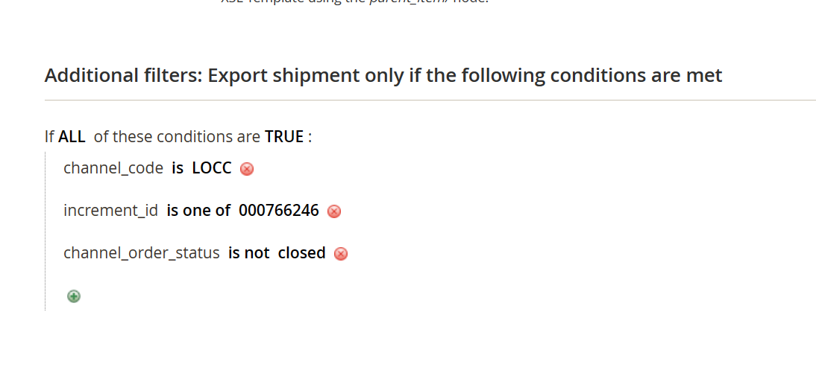

* Klik Save, dan lakukan step kedua di profile yang automatic profile Netsuite Export LOCC dengan memasukan increment_id di filter nya, hal tersebut dilakukan agar tidak bertabrakan ketika push automatic dan manual.
* Masuk ke ftp terminal dan run command

php bin/magento xtento:orderexport:export 9 ← sesuaikan id profile

1. Kemudian jika di check di netsuite_log_export terdapat error fullfilment bisa lakukan reset export_status dengan query

| UPDATE sales_order SET export_status = NULL WHERE entity_id IN ('masukin entity id sales order'); |
| --- |

1. Kemudian jika export_progress 0 (jarang kejadian), fixingnya dengan check di customer_entity email nya ada ga, dan di replace emailnya
2. QUERY untuk check order yang nyangkut per bulan/tahun (note masukan bulan dan tahun nya sesuaikan)

| SELECT oo.channel_order_increment_id, oo.inserted_at, oo.channel_code, so.entity_id as order_id, ss.entity_id as shipment_id, ss.increment_id, so.export_progress, so.export_status, so.netsuite_internal_id  FROM oms_order oo  LEFT JOIN sales_order so ON oo.oms_order_id = so.entity_id  LEFT JOIN sales_shipment ss ON so.entity_id = ss.order_id  WHERE (so.export_status IN (1, 3) OR so.export_status IS NULL) AND so.netsuite_internal_id IS NULL AND YEAR(so.created_at) = 2023 AND MONTH(so.created_at) = 10; |
| --- |

# Issue Create New location & Create Virtual Stock

* Problem : Create new location & Create Virtual Stock (intermediate)
* Example Slack Thread Issue :

<https://sirclo.slack.com/archives/CSJSZT20Z/p1667188605172869?thread_ts=1667188256.913159&cid=CSJSZT20Z>

* Reason : Penambahan lokasi baru
* Step :
* Akses omslite
* Create new location-Create Virtual Stock , assign location ke masing2 VS
* Add VS to channel in (OMS > Channel > select Channel) contoh ada di ss, harap di note ini multiselect
* source akan kebuat ikut cron jam 20:45  
  <https://sirclo.slack.com/files/U017YNLLWF8/F048R9S5WV8/image.png>

# Issue Check Xsl send to Netsuite

* Problem : biasanya untuk ketidak sesuaian grandtotal dengan discount harus di check Xsl nya
* Step :
* cek ke sales shipment untuk mendapatkan increment id
* insert increment_id ke export profile > profile > output format (bagian kanan atas)
* klik tombol test xsl
* compare ke oms_order table untuk mendapatkan value oms_order_id
* oms_order_id dipake di table sales_order (entity_id)
* misalkan ada perbedaan perlu cek ke table oms_order (custom_order_attributes)

# Issue Virtual Stock tidak sync/qty

* Problem : jika virtual stock tidak sync/qty salable berbeda antara oms dan channel
* Example Slack Thread Issue :

<https://sirclo.slack.com/archives/CSJSZT20Z/p1672972692018709>

* Reason : virtual stock belum ditambahkan ke channel
* Step Fixing :
* go to omslite Catalog Inventory > Virtual Stock
* search channel name yang bermasalah > view
* assign location virtual stock context : channel gak dapet karena result karena location BECM-P belum di assign di VS (virtual stock) punya BECM-P